Module 5: Advanced

# Regression:

Regression is a statistical method used in machine learning to model the relationship between a dependent variable and one or more independent variables. It aims to find the best-fit line (or curve) that predicts the dependent variable based on the given independent variables.

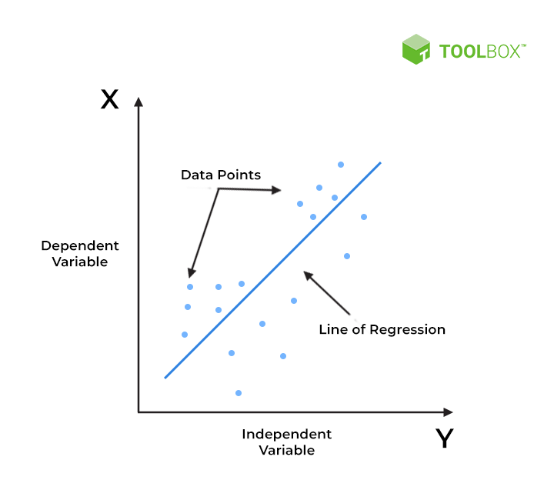

Figure: Best Fit Line for a Linear Regression Model

Example: Simple Linear Regression

import numpy as np

from sklearn.linear_model import LinearRegression

# Sample data

X = np.array([1, 2, 3, 4, 5]).reshape(-1, 1)

y = np.array([2, 4, 5, 4, 5])

# Create a linear regression model

model = LinearRegression()

# Fit the model to the data

model.fit(X, y)

# Predict values

predictions = model.predict([[6]])

print(predictions)

In this example, a simple linear regression model is created using the LinearRegression class from scikit-learn. The model is trained on sample data (X and y), and predictions are made for a new data point ([6]).

# Correlation Matrix:

A correlation matrix is a table showing correlation coefficients between variables. Each cell in the table represents the correlation between two variables. It is a crucial tool for understanding the relationships between variables in a dataset.

Example: Generating a Correlation Matrix

import pandas as pd

# Sample dataset

data = {'A': [1, 2, 3, 4, 5],

'B': [5, 4, 3, 2, 1],

'C': [2, 3, 1, 4, 5]}

df = pd.DataFrame(data)

# Calculate the correlation matrix

correlation_matrix = df.corr()

print(correlation_matrix)

This example uses the Pandas library to create a DataFrame and calculates the correlation matrix using the corr() method.

**How to Read a Correlation Matrix?**

* Look at the number in each cell to see the strength and direction of the correlation.
* Positive numbers indicate positive correlations, while negative numbers indicate negative correlations.
* The closer the number is to 1 (or -1), the stronger the correlation.
* A number of 0 means there is no correlation between the two variables.

# Linear Regression:

Linear regression is a type of regression analysis that models the relationship between a dependent variable and one or more independent variables. The relationship is modeled using a linear equation.

Example: Multiple Linear Regression

import numpy as np

from sklearn.linear_model import LinearRegression

# Sample data

X = np.array([[1, 2], [2, 3], [3, 4], [4, 5], [5, 6]])

y = np.array([3, 5, 7, 9, 11])

# Create a multiple linear regression model

model = LinearRegression()

# Fit the model to the data

model.fit(X, y)

# Predict values

predictions = model.predict([[6, 7]])

print(predictions)

This example demonstrates multiple linear regression using scikit-learn. The model is trained on sample data with two independent variables (X) and predicts values for a new data point ([6, 7]).

# Machine Learning Algorithms:

Machine learning algorithms are computational models that can learn patterns from data and make predictions or decisions without being explicitly programmed. Various algorithms exist for different types of tasks, including classification, regression, clustering, and more.

### Understanding Machine Learning Algorithms

Machine learning algorithms are mathematical models or computational systems that automatically learn patterns and relationships from data without being explicitly programmed. The core idea is to enable computers to improve their performance on a specific task over time by learning from experience or historical data.

#### Learning from Data:

* Machine learning algorithms rely on data to identify patterns and make predictions or decisions.
* The quality and quantity of the data play a crucial role in the performance of these algorithms.

#### Training and Inference:

* During the training phase, the algorithm is exposed to a labeled dataset, where the correct outcomes are provided.
* The algorithm learns to map input features to the correct output or target variable.
* Once trained, the algorithm can make predictions or decisions on new, unseen data during the inference phase.

#### Types of Machine Learning Algorithms:

#### Supervised Learning:

* The algorithm is trained on a labeled dataset, where each input is associated with a corresponding output.
* Common tasks include classification (assigning labels to input data) and regression (predicting a continuous value).

#### Unsupervised Learning:

* The algorithm is provided with unlabeled data and must find patterns or relationships on its own.
* Common tasks include clustering (grouping similar data points) and dimensionality reduction (simplifying data without losing important information).

#### Reinforcement Learning:

* The algorithm learns by interacting with an environment and receiving feedback in the form of rewards or penalties.
* Common tasks include training agents for games or robotics.

#### Common Machine Learning Algorithms:

* Linear Regression:

Predicts a continuous target variable based on linear relationships with input features.

* Decision Trees:

Builds a tree-like structure to make decisions based on input features.

* Support Vector Machines (SVM):

Classifies data by finding the hyperplane that best separates different classes.

* K-Nearest Neighbors (KNN):

Classifies data based on the majority class of its k-nearest neighbors.

* K-Means Clustering:

Divides data into k clusters based on similarity.

* Neural Networks:

Mimics the structure and function of the human brain, consisting of layers of interconnected nodes (neurons).

# Evaluation and Validation:

* Once trained, machine learning models need to be evaluated and validated to ensure their performance on new, unseen data.
* Common metrics include accuracy, precision, recall, F1 score, and others, depending on the nature of the task.

Example: Using a Decision Tree Classifier

from sklearn.datasets import load_iris

from sklearn.model_selection import train_test_split

from sklearn.tree import DecisionTreeClassifier

from sklearn.metrics import accuracy_score

# Load the Iris dataset

iris = load_iris()

X, y = iris.data, iris.target

# Split the dataset into training and testing sets

X_train, X_test, y_train, y_test = train_test_split(X, y, test_size=0.2, random_state=42)

# Create a decision tree classifier

classifier = DecisionTreeClassifier()

# Train the classifier

classifier.fit(X_train, y_train)

# Make predictions on the test set

predictions = classifier.predict(X_test)

# Evaluate accuracy

accuracy = accuracy_score(y_test, predictions)

print("Accuracy:", accuracy)

In this example, a decision tree classifier is trained on the Iris dataset, and its accuracy is evaluated on a test set.